**Capstone Project Phase A**

**25-1-R-5**

**ParkSmart**

Research of Pattern Identifying and Presentation Based on Personal Data for Support and Quality of Life Improvement for Parkinson's Patients.

**Supervision:**

**Dr. Julia Sheidin**

**Dr. Avital Shulner Tal**

**Noam Vallach –** [**Noam.vallach@e.braude.ac.il**](mailto:Noam.vallach@e.braude.ac.il)

**Yuval Shekel –** [**Yuval.shekel@e.braude.ac.il**](mailto:Yuval.shekel@e.braude.ac.il)

[**GitHub**](https://github.com/YuvalShekel1/ParkSmart) **link**

**Table of Contents**

Abstract 1

1. Introduction 1

2. Background and Related Work 3

2.1. Parkinson's Disease 3

2.2. Processing the Data Collected from the Patient 3

2.3. Tools (technologies) for Identifying Patterns in Medical Data 5

2.4. XAI Tools 6

3. Expected Achievements 8

4. Research Process 8

4.1 Data Pre-Processing 9

4.2 Architecture and Tools 10

4.3 GUI 11

4.4 Next Phase Process 13

4.5 Challenges 15

5. Evaluation Plan 15

References 17

Abstract  
Parkinson's disease (PD) is a neurodegenerative disorder characterized by motor symptoms such as tremor, bradykinesia, and rigidity, as well as non-motor symptoms such as depression, sleep disturbances, and cognitive impairment. While there is no cure for the disease, research has shown that a combination of physical activity, proper nutrition, medication, and emotional support can significantly improve patients' quality of life and mitigate symptom progression.

Managing the daily routine of Parkinson's patients consistently and continuously, while relying on personal data, provides essential insights for improving disease management. However, existing tools and methods are not always tailored to the unique needs of each patient and are often cumbersome or limited in their utility.

The goal of our research project is to identify patterns in Parkinson's patients' personal data and to present those patterns in the most effective method, aiming to enhance their understanding and as a result, their quality of life.

To achieve this goal, we will review various tools for identifying patterns in medical data. The identified patterns, based on the patient personal data, may enable Parkinson's patients to gain insights about their disease. Additionally, we will review various formats for presenting these patterns in an understandable way and select the most effective method for presenting the patterns, whether visual, textual, or a combination, to ensure clarity and accessibility.

This project could serve as a significant initial step toward the future development of a personalized recommendation system (based on the patterns of the patient) that will benefit Parkinson's patients and improve their quality of life.

**Keywords:** Parkinson's disease, health data, identifying patterns, presentation of patterns

1. Introduction

Parkinson’s disease (PD) is a neurodegenerative disorder affecting the nervous system, caused by a deficiency of the neurotransmitter dopamine due to the degeneration of cells in the substantia nigra of the brain. PD is characterized by slowed movements, and its clinical symptoms include reduced mobility, muscle stiffness, involuntary tremors, impaired balance, and instability [1,2]. The disease significantly impacts the quality of life, with patients often struggling to perform simple daily activities [8].

PD is incurable, and its treatment typically involves medication alongside alternative therapies aimed at delaying the progression of the disease [6]. Additionally, daily physical activity plays a critical role in improving the functionality of various bodily systems. However, despite the efficacy of medical treatments, physicians face challenges in optimizing medication regimens due to variations in disease progression among patients [7].

In recent years, with the advent of personalized medicine, there is growing recognition that analyzing the habits of Parkinson’s patients, interpreting her personal data, and funding patterns in the data can help in providing tailored recommendations and therefore, can improve their quality of life [9]. This is particularly relevant given the availability of advanced technologies such as artificial intelligence and deep learning. These tools have demonstrated significant effectiveness in analyzing extensive datasets and generating personalized recommendations [10].

Our project follows a **User-Centered Design** approach and is designed for a specific client named Michael, focusing on analyzing his daily habits to improve his quality of life. The project is a continuation of a previous project whose goal was data collection on various aspects, including meal types and times, medication types and schedules, physical activities performed, and their durations. These data will serve as the foundation for analyzing information, finding patterns in the data and presenting them, and as a result, the patient will be able to draw insights, and his doctor may use these patterns to create personalized recommendations aimed at improving her quality of life.

In addition to finding patterns based on the patient’s individual data, we aim to identify the most effective method for delivering this information to patients. Our study investigates how insights can be presented to Parkinson’s patients in a way that maximizes their utility, whether through visual, textual, or combined formats.

Hence, the objective of this research is to review pattern identifying tools for Parkinson’s patients, analyze it, and present them in the most comprehensible and effective manner. By doing so, we aim to empower patients to implement these insights to enhance their quality of life.

2. Background and Related Work

2.1. ****Parkinson's Disease****

PD is a neurodegenerative disorder of the central nervous system that affects both motor and non-motor systems. The symptoms of this disease typically develop gradually, with non-motor issues becoming more prevalent as the disease progresses. Common motor symptoms include tremors, bradykinesia (slowness of movement), rigidity, and difficulty maintaining balance (parkinsonism) [1,2]. In later stages, additional conditions such as PD dementia, involuntary falls, and neuropsychiatric problems like sleep disorders, psychosis, mood changes, or behavioral alterations may develop [11].

PD occurs due to a deficiency of the neurotransmitter dopamine caused by the degeneration of nerve cells in the substantia nigra [3]. The exact cause of this neuronal degeneration is unknown. However, it appears to result from a combination of genetic and environmental factors [4]. For instance, some patients exhibit a mutation in the **SCAN** gene, which encodes the alpha-synuclein protein. This mutation leads to the accumulation of large quantities of the protein, causing neuronal dysfunction and cell death [5]. In other cases, exposure to toxins such as manganese or neurotoxins has been linked to neurological damage, ultimately leading to the development of PD.

PD is incurable, and treatment aims to slow its progression and prevent severe deterioration of the nervous system. Pharmacological treatments include dopamine agonists and dopamine inhibitors [6]. Additionally, physical activity and cognitive exercises are significant for preserving brain function [7].

2.2. Processing the Data Collected from the Patient

Since each patient experiences Parkinson's symptoms uniquely, accurate assessment of symptoms and medication efficacy is essential to enable specialists to evaluate disease progression and patient response to interventions [12]. Typically, Parkinson’s patients receive holistic care from a multidisciplinary team of professionals, including neurologists, movement disorder specialists, physiotherapists, psychologists, and dietitians, aimed at improving the independence and quality of life of Parkinson's patients [13]. Monitoring and evaluating Parkinson's symptoms and disease progression are primarily based on medical history, self-reported data, and neurological assessments such as the Unified PD Rating Scale (UPDRS).

The system we are researching is designed to be personalized for a specific patient and is based on data collected in a previous project focused on patient data gathering. This dataset includes detailed information about the patient's daily routine, such as mealtimes and contents, sleep and wake times, physical activities performed, medication schedules and types, and records of relevant symptoms. However, the collected data is currently presented in a raw and unstructured form in an Excel file, necessitating pre-processing to make it suitable for use with advanced analytical tools. Table 1 presents the data collected by the patient and how it is currently presented.

Table 1. Patient data

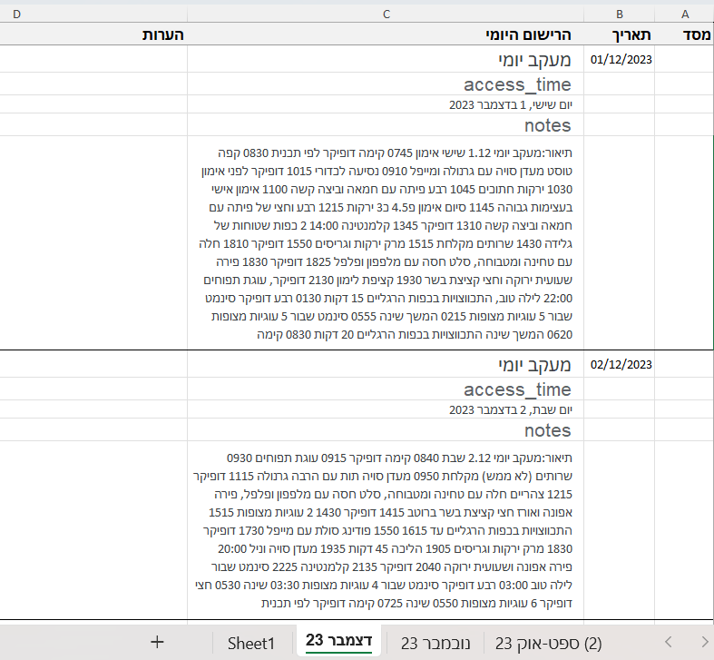

2.3. Tools (technologies) for Identifying Patterns in Medical Data

The analysis of large volumes of digital patient data is essential for deriving characteristics and patterns of patient groups. Pattern identifying provides essential tools for data analysis tasks in the healthcare domain. Specifically, machine learning and deep learning techniques have been successfully applied to various tasks in healthcare, such as risk prediction, disease progression forecasting, and patient sub-classification [18].

For this purpose, tools for pattern identifying are utilized. Below, we present two key tools: Weka and SVM. These tools are used, among other applications, for recognizing patterns in medical information. They are widely employed in academic research in this field due to their advanced classification capabilities and ability to perform sophisticated regression analyses.

The Waikato Environment for Knowledge Analysis (Weka) is a machine-learning toolkit developed by the University of Waikato in New Zealand. It is open-source software written in Java (licensed under the GNU General Public License) and is particularly suitable for academic research due to its user-friendly design. The software operates on Windows, Linux, and Mac operating systems. Weka includes a collection of machine learning algorithms designed to perform data mining tasks. The tool is based on a graphical user interface (GUI) and is primarily used for data preprocessing, evaluation methods, and comparing learning techniques [17].

Due to its ease of use and operation, Weka is considered popular among data scientists and researchers, as mentioned. This is attributed to several main features: First, the graphical user interface (GUI) allows users to explore data, apply machine learning algorithms, and predict outcomes without requiring extensive programming knowledge. Second, the software's rich algorithm library enables its use for various tasks, including regression, classification, and association rule mining. Third, the software offers extensive options for data preprocessing, such as data cleaning, normalization, and feature selection, to prepare data for analysis.  
Fourth, Weka can be integrated with other programming languages, such as R and Python.  
Fifth, data can be easily imported and exported from the software, as it supports various data formats (CSV, ARFF, Excel). Sixth, the software provides multiple data presentation tools, including histograms, scatter plots, and decision trees. Seventh, as an open-source platform, the software can be extended by adding algorithms or new features, allowing for customization and tool enhancement. Despite these advantages, the software also has limitations. Its scalability is limited, as it struggles to handle very large datasets. In addition, the software does not support multi-relational data mining and does not natively support sequence modeling, which restricts its use in certain applications [19].

Support Vector Machine (SVM) is a supervised learning technique used for data analysis in classification and regression tasks. This method represents training examples as vectors in a linear space. For classification problems, the training phase involves fitting a classifier that separates positive and negative training examples as accurately as possible. The classifier generated by SVM is a linear separator that maximizes the margin between itself and the nearest examples from both categories. When a new point is presented, the algorithm determines whether it falls within the boundary defining the group or outside of it.

SVM is not restricted to linear classification and can also perform non-linear classification by employing a kernel function, which maps the input into a higher-dimensional space [20].

SVM performs well with high-dimensional data, which is common in medical datasets that contain numerous features. Additionally, SVM is robust to overfitting, making it particularly effective when the number of dimensions exceeds the number of samples. This ability helps the model generalize well to unseen data. The kernel trick is another strength of SVM, as it can handle non-linear relationships, which is beneficial for identifying complex patterns in medical data. Moreover, SVM tends to offer high accuracy in classification tasks, which is crucial for medical diagnostics. However, SVM can be computationally intensive, often being slow and consuming considerable memory, particularly with large datasets. Another limitation is the need for careful tuning of hyperparameters, such as the regularization parameter and kernel parameters. This tuning process can be complex and time-consuming.

In summary, Weka offers a user-friendly machine learning tool with a graphical interface rich in algorithms but struggles with large-scale data analysis. While SVM provides accurate classification and robustness to overfitting but requires complex tuning and high computational resources.

2.4. XAI Tools

The use of advanced algorithms and technologies to identify patterns in medical information, including patterns of PD, is thriving. However, most artificial intelligence algorithms operate as black boxes and lack explainability. Therefore, Explainable Artificial Intelligence (XAI) helps understand the decisions and reasoning behind computational model predictions, provides explanations for how a particular conclusion was derived, and enhances trust among both users and experts regarding the reliability of the results.

We will briefly introduce the most popular tools for providing AI explainability (XAI): Local Interpretable Model-Agnostic Explanations (LIME) and Shapley Additive Explanations (SHAP). LIME and SHAP are general-purpose, ready-to-use tools designed to offer explainability to users, mainly suited for developers of AI algorithms [16]. These explanations can be presented visually, textually, or in a combined manner.

SHAP (Shapley Additive Explanations) is a method for explaining model predictions by calculating the contribution of each feature to a specific prediction. The method is based on Shapley values, which estimate the marginal contribution of each feature across all possible coalitions. In other words, it quantifies how each feature influences the model's prediction compared to other features. This approach enables a clear understanding of which features contributed to the model's predictions and why. It presents their impact visually and provides textual descriptions, especially for models involving images [14].

LIME (Local Interpretable Model-Agnostic Explanations) is a method that explains model predictions by approximating them locally with a simple and interpretable model. The method focuses on local fidelity, meaning it provides visual and textual explanations for individual predictions tailored to the specific conditions under which the prediction was made. The process involves generating new samples that yield predictions from the original model, with each sample evaluated based on its proximity to the instance being analyzed. LIME then constructs a linear model to describe the contribution of each feature in the decision-making process for that prediction. This method is applicable to any machine learning model, regardless of its type [15].

In summary, SHAP provides consistent, theory-based explanations suitable for complex models, while LIME offers flexible local explanation solutions that are adaptable to different models and provide simpler insights.

**3. Expected Achievements**

In our project, we focus on identifying patterns based on the collected data and presenting them to the patient. This data is particularly relevant for a Parkinson’s patient, as it enables monitoring of factors influencing symptoms and treatment response, such as sleep patterns, physical activity, and adherence to medication schedules. Our project will serve as a continuation of the previous project, with the goal of advancing the data collection and analysis process. The identified patterns may help the patient improve his quality of life and adapt treatment to his individual condition.

The identified patterns and their presentation will benefit the patient by simplifying the process of understanding the impact of various activities on his condition, allowing him to make informed decisions and maintain a high quality of life.

The success of the project will be evaluated based on several criteria, including a comparison between the different tools used for pattern detection. We will examine whether the tools identified the same patterns, the relevance of the patterns found, and whether meaningful insights can be drawn from them. Additionally, we will assess the effectiveness of the patterns through feedback from Michael, for whom the system is designed, to determine whether the patterns are beneficial to him and whether he intends to make any lifestyle changes based on the information provided.

Ultimately, this project has the potential to serve as a foundation for future advancements in personalized medical tools, particularly for neurodegenerative diseases, through the presentation of data-based insights via accessible user interfaces.

4. Research Process

The project began under the guidance of our supervisors, who introduced the idea of analyzing Parkinson's patient data and identifying and presenting patterns. During the initial meetings, they presented the data collected from a Parkinson's patient as part of a previous project. This data included information about daily activities, medication schedules, sleep routines, nutrition, and symptoms. These datasets served as a foundation for understanding the complexity and challenges of managing the disease and inspired us to explore ways to utilize this information for the purpose of improving the patient's quality of life.

Following the initial discussions, we focused on researching a system that could analyze daily routines and provide actionable patterns that enable gaining insights to enhance the quality of life for Parkinson's patients. Our research centered on identifying the most effective methods for utilizing the data and , finding relevant patterns and presenting them to the patient. We reviewed existing literature on similar systems and explored tools and techniques in data analysis, machine learning, explainable ai and user experience design to ensure our approach was both scientifically robust and user-friendly.

During the semester, we met with Michael, the specific client for the system, in order to clarify his needs. We explained the project to him, and he mentioned that the most important thing for him is that we focus on identifying patterns related to nutrition, but also requested that we look for all patterns in general. Additionally, he emphasized that it is important for him that we identify both the positive and negative patterns.

4.1 Data Pre-Processing

At the current stage of the project, we focused on understanding the collected data to identify its structure and key characteristics. In the next stage, we will perform preprocessing of the data to convert it into a format suitable for the analytical tools we plan to use. This process will ensure that the data is prepared and optimized for complex analyses, enabling accurate identification of relevant patterns.

The data collected from the patient includes detailed hourly information about his nutrition, medication intake, physical activity, sleep patterns, etc. This data directly influences the central variables, which is the patient's overall feeling and the Parkinson’s condition. In order to understand the relationships between these variables, we aim to identify patterns that show how each variable, as well as the combination of them, impacts the overall feeling and Parkinson’s condition. For example, whether protein consumption affects the Parkinson’s symptoms, if engaging in physical activity in the morning contributes to improving the patient's overall feeling, whether consuming proteins after physical activity affects the Parkinson’s symptoms, etc.

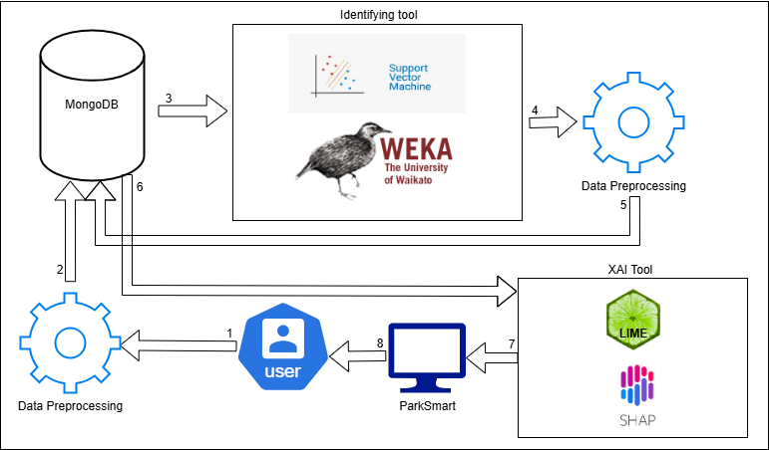4.2 Architecture and Tools

The architecture diagram represents the system's workflow, starting with the user collecting data. The collected data undergoes data preprocessing to prepare it for the selected pattern identification tool(1). This preprocessed data is then stored in a MongoDB database(2). Following this, the selected pattern identification tool is used to analyze the data and identify meaningful patterns using the preprocessed data stored in the database(3). The results from this analysis are further processed with data preprocessing to ensure they are compatible with the selected tool for pattern presentation(4). The preprocessed data is then stored in a MongoDB database(5), and the pattern presentation tool utilizes the processed data from the database to display the identified patterns(6). The results are then displayed in the ParkSmart system(7), allowing the user to view the identified patterns and benefit from the system(8).

4. 3 GUI

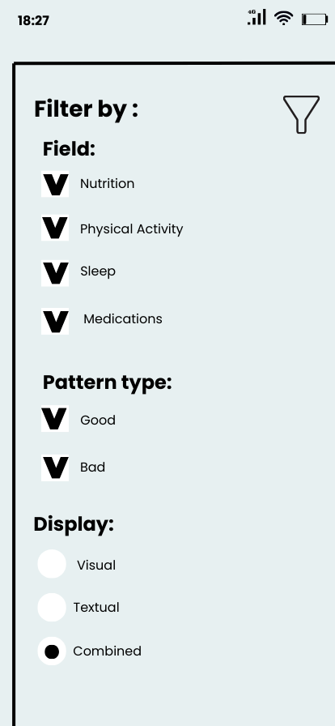The system includes dedicated screens that allow Michael to explore and customize the patterns he wants to view, including the option to filter patterns as positive, negative, or both, while also selecting his preferred method of presentation.

This is the filtering screen, allowing Michael to choose the category in which he wants to view patterns: nutrition, physical activity, sleep, or medication. He can select a single category, multiple categories, or all of them together. Additionally, based on his request, we have added the option to filter between good patterns, bad patterns, or display both simultaneously. Finally, Michael will be able to decide how the patterns will be presented -visually, textually, or a combination of both, according to his preference.

תמונה שמכילה טקסט, צילום מסך, תוכנה, סמל מחשב

תוכן שנוצר על-ידי בינה מלאכותית עשוי להיות שגוי.

This screen displays patterns based on the filters selected in the previous step, combining both visual and textual representations to provide a comprehensive view of the patient's general feeling and his Parkinson's symptoms. The visual display features a graph where the patient's general condition (represented by blue dots) and Parkinson's condition (represented by yellow dots) are plotted on a scale from 1 to 5. The x-axis displays the patient's daily activities across categories such as nutrition, physical activity, and sleep, allowing the patient to observe how specific activities impact their condition by analyzing trends in the rise and fall of the points. Below the graph, the textual display lists identified patterns, with green dots indicating positive effects and red dots indicating negative effects. For example, the system might show that after sleep, the general feeling is above 3, after consuming carbohydrates, Parkinson’s condition ranges between 1.5–2.5, or that after training, Parkinson's condition improves by at least two levels. This combination of visual and textual insights helps the patient understand how specific activities influence their general feeling and Parkinson's symptoms, enabling them to make informed decisions to optimize their routine.

4.4 Next Phase Process

At this stage, we have reviewed the various tools, but we have not yet selected the final tools, as we want to first experiment with them to understand how they work and what results they provide. Based on this, we will make an informed decision on choosing the most suitable tool.

In the next stage, we will review the tools presented in the literature review and choose the most suitable tool for identifying patterns from the collected data. Afterward, we will preprocess the patient’s data and integrate it into the selected tool for pattern identifying. Subsequently, we will evaluate the tools we introduced for presenting the patterns and ultimately select the one most appropriate for displaying the identified patterns. We will gather feedback from Michael and refine the system based on his comments and needs to ensure it is accurate, relevant, and meaningful for him. The entire process will be presented in a float chart to help understand the workflow of the project.

*תמונה שמכילה טקסט, צילום מסך, תרשים, גופן

תוכן שנוצר על-ידי בינה מלאכותית עשוי להיות שגוי.float chart of work process*

4.5 Challenges

The challenges in our project are numerous and varied. First, this is a continuation project, and at this stage, we are still unsure how we will proceed – whether we will rely on the system developed in the previous project, connect a new system to the existing one, or choose another solution. This question requires in-depth consideration of different options, and its impact on the further work could be significant.

Additionally, using the various tools in the project requires deep knowledge and understanding to make the most of them. It is important to ensure that the patterns that will be identified by the tools are indeed correct and relevant, and that they point to real connections that can help improve Michael’s condition. This means we will need to learn and understand each tool thoroughly to use them as effectively as possible.

Another challenge relates to the integration between the different tools. We need to find a way to integrate the tools so that the tool designed for presenting the patterns will display the patterns identified by the identifying tool will in a clear and understandable way. One of the central questions is whether the tools will naturally be compatible with each other, or if we will need to make further adjustments to ensure the process works smoothly.

Furthermore, we must ensure that the patterns presented to Michael are not only correct but also clear, relevant, and helpful for him. The goal is to present insights that will help him understand the impact of his daily activities on his condition and improve his quality of life. Therefore, the patterns must be presented in a way that is understandable, accessible, and useful.

5. Evaluation Plan

To ensure the system operates correctly and as intended, we will evaluate it through the following steps:

1 .Execute the testing plan.

2 .Have the system used by real user

This test plan outlines the strategy for testing and evaluating of the relevance and accuracy of the patterns provided by the system and of presenting the patterns in a clear and understandable way. This test plan aims to ensure that the system meets its requirements and performs as expected.

To evaluate the success of the project from a technical perspective, we will assess the suitability of the tools used in the system for the intended purpose, ensuring they can effectively identify relevant patterns from the data. Additionally, we will examine the system's operation itself, ensuring it functions smoothly, performs the required tasks, and presents the patterns clearly, accurately, and usefully. Furthermore, we will evaluate the compatibility and integration of the different tools to ensure that the system operates seamlessly and effectively combines all the tools.

From a user evaluation perspective, the primary focus will be to ensure that the patterns presented to Michael are not only clear and understandable but also relevant and beneficial in improving his condition. We will assess the added value of the patterns compared to the raw data presentation, making sure the patterns provide a significant advantage by allowing Michael to draw conclusions that can lead to practical improvements in his daily life. Our goal is to ensure that the displayed patterns will assist Michael and contribute to improving his quality of life.

References

[1] Bhattacharyya, K. B. (2017). Hallmarks of clinical aspects of Parkinson's disease through centuries. In K. P. Bhatia, K. R. Chaudhuri, & M. Stamelou (Eds.), Parkinson's Disease. International Review of Neurobiology (Vol. 132, pp. 7). Academic Press.

[2] Stanford Parkinson's Community Outreach. (2025). *Stanford University School of Medicine*. Retrieved January 3, 2025.

[3] Ramesh, S. D., & Arachchige, A. S. (2023). Depletion of dopamine in Parkinson's disease and relevant therapeutic options: A review of the literature. *AIMS Neuroscience, 10*(3), 201–203.

[4] Morris, H. R., Spillantini, M. G., Sue, C. M., & Williams-Gray, C. H. (2024, January). The pathogenesis of Parkinson's disease. *Lancet, 403*(10423), 293–304.

[5] Calabresi, P., Mechelli, A., Natale, G., Volpicelli-Daley, L., Di Lazzaro, G., & Ghiglieri, V. (2023). Alpha-synuclein in Parkinson's disease and other synucleinopathies: From overt neurodegeneration back to early synaptic dysfunction. *Cell Death & Disease, 14*(3), 176, 1–5.

[6] Bie, R. M., Clarke, C. E., Espay, A. J., Fox, S. H., & Lang, A. E. (2020, March). Initiation of pharmacological therapy in Parkinson's disease: When, why, and how. *Lancet Neurology, 19*(5), 452–461.

[7] Ahlskog, J. E. (2011, July). Does vigorous exercise have a neuroprotective effect in Parkinson disease? *Neurology, 77*(3), 288–294.

[8] Bohanec, M., Miljković, D., Valmarska, A., Mileva Boshkoska, B., Gasparoli, E., Gentile, G., Konitsiotis, S. (2018). A decision support system for Parkinson disease management: expert models for suggesting medication change. *Journal of Decision Systems*, *27*(sup1), 164–172. <https://doi.org/10.1080/12460125.2018.1469320>.

[9] Titova, N., & Chaudhuri, K. R. (2017). Personalized medicine in Parkinson's disease: Time to be precise. *Movement disorders : official journal of the Movement Disorder Society*, *32*(8), 1147–1154. [https://doi.org/34.1002/mds.27027](https://doi.org/10.1002/mds.27027)

[10] Coelho, B. F. O., Massaranduba, A. B. R., Souza, C. A. d. S., Viana, G. G., Brys, I., & Ramos, R. P. (2023). Parkinson’s disease effective biomarkers based on Hjorth features improved by machine learning. *Expert Systems with Applications, 212*, 118772

[11] Bohanec, M., Miljković, D., Valmarska, A., Mileva Boshkoska, B., Gasparoli, E., Gentile, G., Konitsiotis, S. (2018). A decision support system for Parkinson disease management: expert models for suggesting medication change. Journal of Decision Systems, 27(sup1), 164–172. <https://doi.org/10.1080/12460125.2018.1469320>

[12] Evers, L. J. W., Peeters, J. M., Bloem, B. R., & Meinders, M. J. (2023). Need for personalized monitoring of Parkinson's disease: the perspectives of patients and specialized healthcare providers. Frontiers in neurology, 14, 1150634. <https://doi.org/10.3389/fneur.2023.1150634>

[13] J. Cancela, M. Pastorino, M. T. Arredondo, and O. Hurtado. 2013. A telehealth system for Parkinson’s disease remote monitoring. In Proceedings of the 2013 35th Annual International Conference of the IEEE Engineering in Medicine and Biology Society (EMBC). 7492–7495.

[14] Zhang, K., Xu, P., & Zhang, J. (2020, October). Explainable AI in deep reinforcement learning models: A shap method applied in power system emergency control. In *2020 IEEE 4th conference on energy internet and energy system integration (EI2)* (pp. 711-716). IEEE.‏

[15] Lundberg, S., & Lee, S. (2017). A unified approach to interpreting model predictions. *CoRR, abs/1705.07874*.

[16] Hossain, M. I., Zamzmi, G., Mouton, P. R., Salekin, M. S., Sun, Y., & Goldgof, D. (2023). Explainable AI for Medical Data: Current Methods, Limitations, and Future Directions. *ACM Computing Surveys*.‏

[17] Singhal, S., & Jena, M. (2013). A study on WEKA tool for data preprocessing, classification and clustering. *International Journal of Innovative technology and exploring engineering (IJItee)*, *2*(6), 250-253.

[18] Baytaş, İ. M., Peng, Y., & Özgür, A. (2023). Editorial: Pattern recognition for healthcare analytics. *Frontiers in digital health*, *5*, 1186713. ‏

[19] (August 22, 2024) *Introduction to Weka: Key Features and Applications*<https://www.geeksforgeeks.org/>.

[20]Cervantes, J., Garcia-Lamont, F., Rodríguez-Mazahua, L., & Lopez, A. (2020). A comprehensive survey on support vector machine classification: Applications, challenges and trends. *Neurocomputing, 408*, 189-215. <https://doi.org/10.1016/j.neucom.2019.10.118>.